2025

1930

St. Paul the Apostle

Maltese-Canadian Parish

**t. aul the Apostle Maltese-Canadian Parish**



**3224 Dundas Street West, Toronto, Ontario M6P 2A3 Tel 416-767-7054**

Email:[stpaultheapostleto@archtoronto.org](mailto:stpaultheapostleto@archtoronto.org)

Website: stpaultheapostleto.archtoronto.org

**Pastoral Team** Fr. James Bussanich, p.p. Deacon Raymond Frendo

**Secretary** Mrs. Rita Apalit

**OFFICE HOURS** Monday to Thursday 8:30am to 4:00pm

Friday 8:30am to 12:00noon

**MASS SCHEDULE** Wednesday & Friday 9:15am (Maltese/English)

Tuesday & Thursday 9:15am First Saturday of the month 9:15am

**Weekend Masses:** Saturday:4:30pm (English)

Sunday:9:00am (English) 10:30am (Maltese/English) 12:00pm (English)

**Weekly Adoration of the Blessed Sacrament:** Wednesdays 7pm - 8pm

**SACRAMENTS Baptism:** Please contact the priests. Baptisms are held on the first Saturday of the month at 10:30am **Marriages:** Contact the priest one year in advance of the wedding. A marriage preparation course in mandatory. **Sacrament of Reconciliation:** First Friday: 8:40am to 9:10am Saturdays: 3:45pm to 4:15pm **Anointing of the Sick:** Contact the priests. Parishioners are reminded that this is not a sacrament that should be left for the last possible minute. It is a Sacrament for the sick, not just for the dying.

**September 13th/14th - Twenty-Third Sunday in Ordinary Time**

**Saturday, September 6** 4:30pm (d)Charlie & Christina Cini

**Sunday, September 7** 9:00am   For the People of the Parish

10:30am (d)Benjamin Paul Haber (d)Rita Caruana

(d)Vic & Josephine Attard & Family

(d) Mary & John Fenech

(d) John & Anthony Sultana

12:00pm (d)Frank Cini

**Tuesday, September 9** (d)Zammit & Cutajar Families

**Wednesday, September 10** (d)Mario Mifsud

**Thursday, September 11** (d)Frank & Gustav Grech

**Friday, September 12** Thanksgiving – Maria & Manuel Candelaria

–50th Wedding Anniversary

***We will begin First Saturday Masses here at St. Paul’s,***

***starting on Saturday, Oct. 4, at 9:15am.***

The First Saturdays Devotion, also known as the “Five First Saturdays” is a special request by Our Lord and Our Lady to make reparation for all the sins against the Immaculate Heart of Mary. Our Lady promised personal salvation if we fulfill the five consecutive First Saturdays. However, we should continue to fulfill them every month to console the Hearts of Jesus and Mary and make reparation for the sins of others. The continued practice of the First Saturdays will help bring about a period of peace and the salvation of many souls as Our Lady promised (Fatima, July 13, 1917).

*Jesus & His Mother Made a Special Request for the First Saturdays*

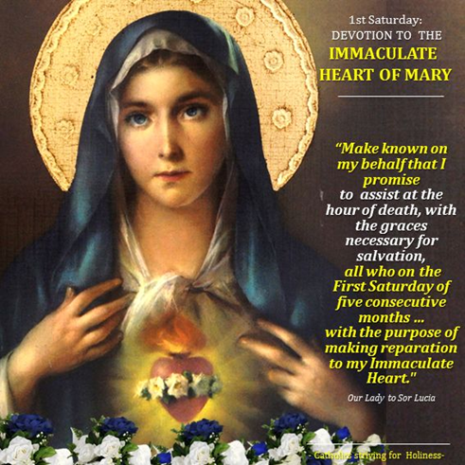

**ShareLife: From the heart of the Church – Food Security Grants to fight hunge**

As food insecurity worsens across the GTA, ShareLife, Catholic Charities of the Archdiocese of Toronto (CCAT), and two generous anonymous donors, have pledged a combined $800,000 in Food Security Grants for 2025—building on previous commitments of $500,000 in 2023 and $750,000 in 2024.

Living the Gospel means caring for those who are hungry and vulnerable every single day. This is why we need your help to reach our parish goal. We have currently raised **$11,700.00** towards our suggested goal of **$18,500.00**. Please help fight hunger through sharelife.org/donate or by giving at our parish using a ShareLife envelope. Thank you for your kind generosity!

**ANNOUNCED MASS INTENTIONS**

MASS INTENTIONS FOR

2025 ARE FULLY BOOKED.

**WE WILL NOT BE TAKING MASS INTENTIONS FOR 2026 UNTIL FURTHER NOTICE.**

**WEDNESDAY ADORATION**

Join us for Wednesday Adoration, held every Wednesday from 7:00 pm to 8:00 pm.

ALL ARE WELCOME!

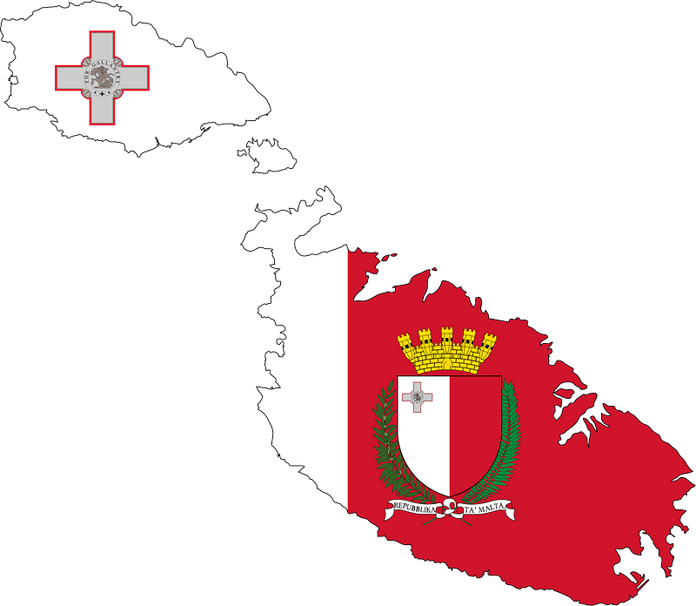

**MALTA’S INDEPENDENCE DAY**

**-SEPTEMBER 21-**

On Sunday, September 21st at the 10:30 am Mass, join us as we celebrate Malta’s Independence Day.

We invite and encourage all to attend this wonderful event. After the Mass we will continue celebrating this special day with a reception in the lower hall.

HOPE TO SEE YOU ALL THERE!

**95TH ANNIVERSARY OF ST. PAUL THE APOSTLE PARISH**

As we gather to celebrate the 95th anniversary of our parish, we reflect on the rich history and enduring legacy of our beloved parish. On September 8, 1930, our parish was established from the desire of the Maltese immigrants who settled in Toronto and sought a place to worship and build a community. May God reward them for their courage and dedication. Our parish has been through a lot of rewarding and challenging periods. May God continue to bless our parish, through the intercession of St. Paul, now and in the years to come.

Join us on **Saturday, October 4**, following the **4:30 PM Mass**, for our **Annual Parish Anniversary Dinner Dance**!

* Full Course Meal
* Cash Bar (one free drink ticket per guest

Come celebrate with great food, music, and fellowship as we mark another wonderful year together.

**Tickets:**

* **Adults:** $60.00
* **Children (ages 5–11):** $30.00

For tickets call Freda at 416-762-1891 or the parish office at 416-767-7054

Hope to s ee you all there!

*\*\*All proceeds will go towards the purchase of a new fridge and oven for the kitchen in our lower hall.\*\**

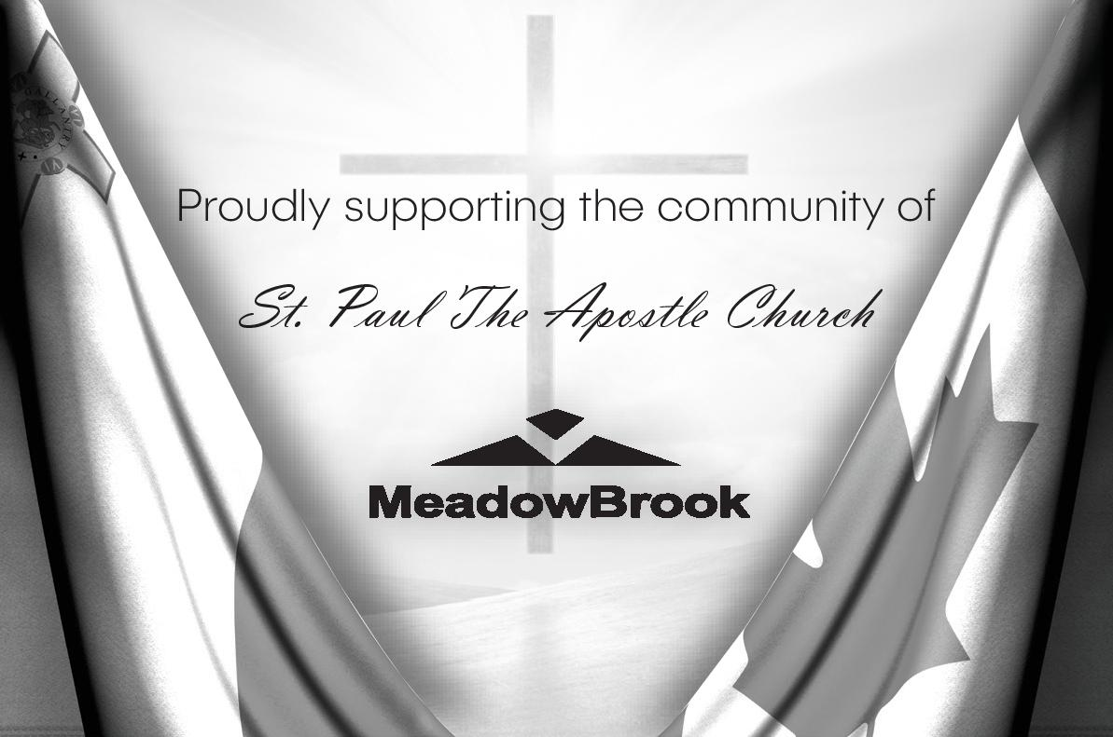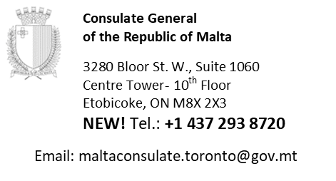

Compliments of

**Melita S.C. Inc.**

3336 Dundas St. W

Toronto, Ontario

M6P 2A4

Tel: 416- 763-5317

www.melitasoccerclub.com



**CATHOLIC CEMETERIES - ARCHDIOCESE OF TORONTO**

**ASSUMPTION CATHOLIC CEMETERY**

**6933 Tomken Road, Mississauga (905) 670-8801**

**Maltese Section, Mausoleum, Cremation and Monument Lots.**

***Visit our website at www.catholic-cemeteries.com***

 At a time of need, or when planning ahead,

rely on the trusted specialists.

**Call 416 767-1176**

3299, Dundas Street West, Toronto

(One block east of Runnymede)

**www.lynettfuneralhome.ca**

*Please support these people who are advertising in our Bulletin.*

*Through their sponsorship they are assisting the daily running of our Parish.*

**AMANTINE**

**SECURITY**

**SYSTEM**

**24 hour Monitoring**

**Professional Security Systems Marc Govè (905) 454-4855**

**CUSTOM HOME BUILDING SINCE 1998**

**LEPREVO.CA**

**MELITA MAINTENANCE INC.**

**Tony Saliba - Bonded & Insured**

24 Hour Service - Complete Janitorial Service

Roofing, Paving/Concrete, Line marking,

Carpet Cleaning - Window Cleaning

Power Sweeping & Power Washing

General Contracting.

**Bus: 416-762-6302 Cell: 416-315-5814**

*Entry Doors, Vinyl & Aluminum Windows. Roofing and Eaves troughing, General*

*Contracting.*

**Angelo Portelli**

Free Estimate

**Home (905) 812-0697; Cell (416) 827-4872**

**Home (905) 812-0697;**

**Cell (416) 827-4872**



Compliments of

**Lehen Malti**

416-571-3944

lehenmalti@hotmail.com

Compliments of

Festa San Gorg

Committee

C

Committee

*www.festasangorg.ca*

Festa San Gorg Association

Founded in 1987

Residential / Commercial / Industrial

Blocked drains & sewers

Boilers / Snow Melt / In-floor heating

Backflow installation & testing

Government Rebates

**Attard Plumbing Ltd**

**416-881-PIPE (7473)**

*Serving the GTA over 30 years*

**MALTA BAKE SHOP**

3256 DUNDAS STREET WEST

Tel: (416) 769-2174

email: maltabakeshopltd@gmail.com

**OPEN 7 DAYS A WEEK**

*Frozen Pastizzi are available at:*

*Messina Bakery, Solero Bakery, Molisana Bakery; Atlantic Bakery; Malta Band Club; Lisboa Bakery; Coppa’s Fine Foods; Highland Farms; Mama Malta Pastizzi; Cedar Nights; Bolton’s Convenience; Maryland Variety; Connor’s Cones & Café; various No Frills; and more than other 30 locations close by.*

***Contact us for more information***

***- Always ready to help you -***

**Pinsa Romana and Italian Cuisine**

*First & Only certified Pinseria in Toronto*

Catering available for large party events

Take-out & Order Online

Tuesday - Sunday at 4pm - 9pm

3076 Dundas St W, Toronto, ON M6P 1Z81

416 766 3841 - www.vengacucina.ca

**MALTA BAND CLUB**

5745 Coopers Avenue

Mississauga, ON L4Z 1R9

**Hall for Rent**

Weddings - Baptisms - Showers

Private Functions

Tel: (905) 890-8507